Challenge Proposal 2

Build a JavaScript quiz

The purpose for this for me would be to use it on activities such as teaching opportunities or just as a game with friends or family. I am aware I would have to change the questions or topics with each different group of people.

For the second challenge I will continue to work on the JavaScript quiz. During the first challenge, the data was written inside the JavaScript file but this time the data will be fetch from an external API of trivia questions I have found available for the use in JavaScript quiz apps. The HTML was also hardcoded inside the HTML file and the changes there will be that only the main frame of the HTML will be in the file and the content will be from the JavaScript file.

I want to add the option of choosing categories as well, so that the user can do the quiz according to their knowledge.

Color scheme for this app is very simple, it will vary between the colors in the following list:

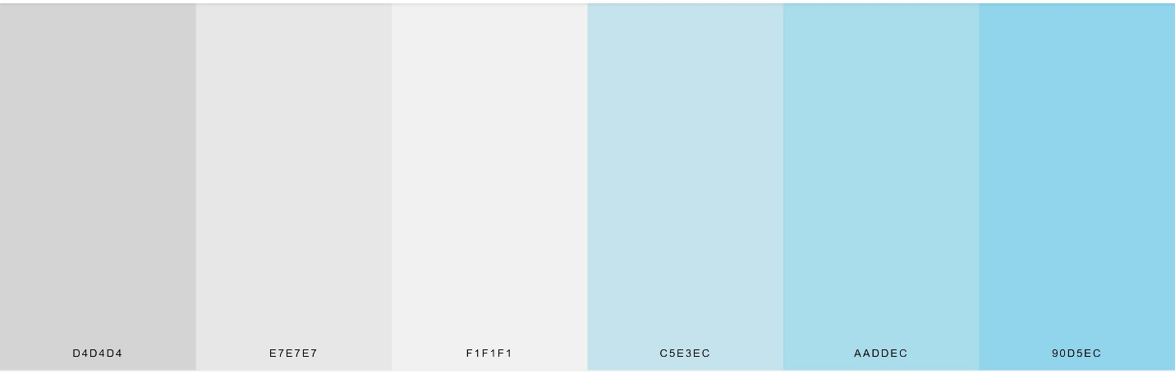

The fonts are also simple, for the main content it will be just Arial, sans-serif, and for the headers it will be:



The main wireframe, which is the one for the quiz contains the questions and multiple choice answers:

